

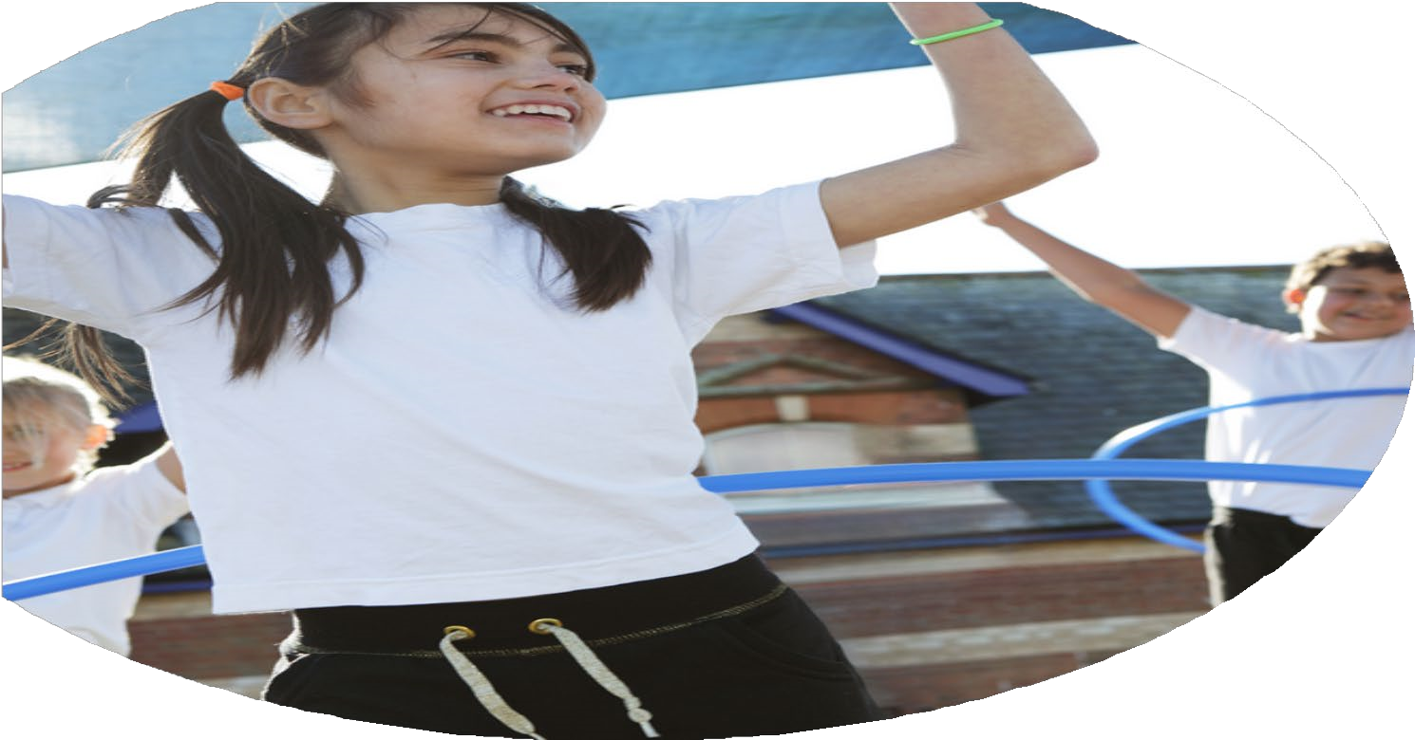
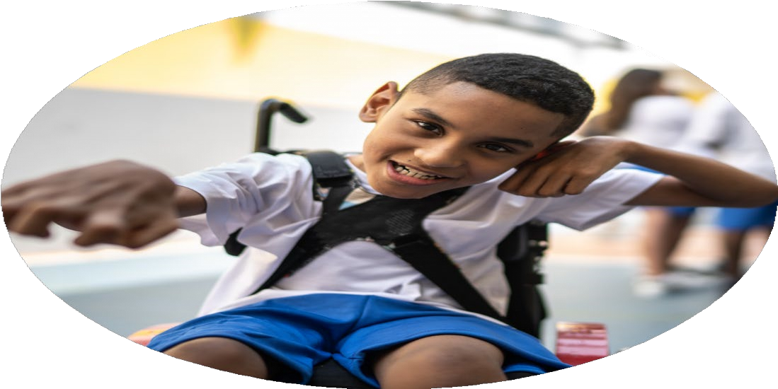
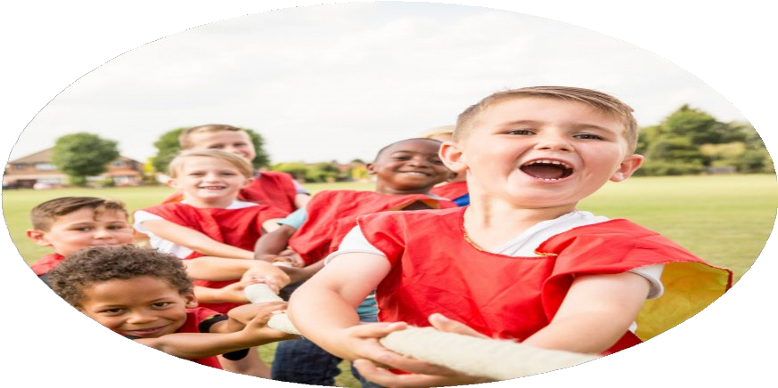



PE Funding
Evaluation Form

Commissioned by

Created by

Images courtesy of Youth Sport Trust

PE Funding Evaluation Form

It is intended that this template should be used as preparation for the completion of the statutory digital reporting tool being introduced this academic year. You can upload data (including swimming) from this template onto this platform once it becomes accessible.
Before you decide how you are going to use the funding for this academic year you should reflect and evaluate the impact of your use of the funding in 2023/24.
All spending of the funding must conform with the terms outlined in the Conditions of Grant document.
The template is a working document that you can amend/update during the year.
Based on your evaluation of last year’s funding you should decide what you intend to do this academic year, how you will do it, and what impact you expect it to have.

It is important that the funding is used effectively and based on your school’s needs.
You must use the funding to make additional and sustainable improvements to the PE and sport in your school. You must develop and add to the PESSPA activities that your school already offers.

Summative digital reporting from June 2025 will continue to include swimming and water safety information therefore funding can be used to provide top-up lessons where necessary to ensure pupils meet national curriculum swimming requirements.

Review of last year 2023/24
We recommend that you start by reflecting on the impact of current provision and reviewing your previous spend
What went well? | How do you know? | What didn’t go well? | How do you know?
-Purchasing and embedding new Complete P.E scheme.  -Children attended competitive football tournament with the school affiliation with Blaydon District. | -New curriculum is being positively embedded across school. P.E coordinator has completed learning walks, pupil voice and staff questionnaires to evaluate the effectiveness of the new scheme. Feedback that was collated was positive.  -Feedback from parents and pupils was very positive after attending the event. The achievements were celebrated in assembly and girls noticeably playing more football on yard at break/lunchtimes. School look to invest more money into this opportunity next year because of its success by purchasing new school football kits. | -Unable to attend as many SSP events to expose children to a range of different sports. | -The school did not attend as many events as the year prior however this is a result of the cost of transport. Following on from this, school will seek to get outside providers to come into schools in academic year 2024/25 to take part in taster sessions with each year groups so that children are still being exposed to a broad range of sports.

Intended actions for 2024/25

What are your plans for 2024/25? | How are you going to action and achieve these plans?
Intent | Implementation
-To offer children the opportunity to be exposed to a broad range of sports.  -To actively engage with local School Games Organiser & The School Games Programme – Aim to maintain GOLD School Games Mark  -To provide each child with a school P.E kit.  -To provide girls and boys with opportunities to play competitive sports.  - To provide transport to attend sporting events.  - Activities planned for targeted children at lunch times and break times to engage the least active children (available to all children). | -P.E coordinator to book outside agencies in for a day to take part in taster sessions in each year group. This will be booked through SSP coaching requests.  - EYFS (Little Kickers October 2024) (Little Rugby May 2025)  - Year 1-4 (Karate-Summer 1)  - Year 5-6 (Fencing- Summer 1)  Swalwell have to take part in a variety of SSP events this year and will continue this in September. PE coordinator has regular meetings with a member of the SSP team/school governor which will continue.  • Meetings with Alex Perkins School governor  • Health & Wellbeing Lead has attended training with SSP networking meeting.  • School Website- Health and Wellbeing https://www.swalwellprimary.org/healthwellbeing/  Swalwell Primary school to maintain SLA with SSP and Health and Wellbeing  School to continue to build P.E kits for each child in school. Plimsoles to be purchased across school so that each child can access P.E with appropriate footwear. This takes pressure off parents to purchase P.E kit as school will be using Sport Premium to fund the cost. This can positively impact sustainability as P.E kits can continue to be used in school for a period of years to ensure each child has the appropriate clothing to access P.E lessons.  -The Blaydon District Football affiliation has been a real positive of last year and as a result we will continue this into this year. This has provided children with experiences of taking part in competitive sport. Furthermore, this has also encouraged positive relationships with the community as community has come to support children.  -Actively engage with SSP and Cross cluster events.  Events attended so far:  Panathalon 11th December 2024 (SEND)  Mini Basketball 27th January  Boccia 2nd Feb 2025  Dance Festival March 2025  Blaydon district football March/April/ May 2025  Extra swimming for some Year 6 learners (January 2025-July 2025)  -Teaching assistant with Sport/P.E as a focus to work alongside P.E lead to ensure that ASD/PD ARMS children have suitable provision on the yard at lunchtimes/breaktimes.  -Teaching assistant with Sport/P.E as a focus to also work alongside P.E lead to ensure that there is suitable equipment on the yard to ensure children are physically active during break/lunchtimes.

Expected impact and sustainability will be achieved
What impact/intended impact/sustainability are you expecting? | How will you know? What evidence do you have or expect to have?
-To offer children the opportunity to be exposed to a broad range of sports.  - To actively engage with local School Games Organiser & The School Games Programme – Aim to maintain GOLD School Games Mark  -To provide each child with a school P.E kit.  To provide girls and boys with opportunities to play competitive sports.  To provide transport to attend sporting events.  - Activities planned for targeted children at lunch times and break times to engage the least active children (available to all children). | -This will be sustainable for future as it exposes children to alternative sports they might not have heard of or taken part in. This could provide children with positive relationships with sport and physical literacy.  P.E lead will complete pupil voice to understand what the impact of this has been and find out what further opportunities they would benefit from.  -This will be sustainable for the future as it will allow children to take part in competitive sport, this could result in children joining extracurricular clubs outside if events are enjoyed. P.E lead to conduct pupil voice to discuss how these opportunities impact the children and what they have gained from being offered these opportunities.  -This will be sustainable as it will promote the profile of PE and sport across school as children will have adequate kit to access P.E lessons. P.E kits can continue to be used within school for following years to come. This also elevates any pressure from parents/carers to provide children with specific kit in a time where living costs are rising.  - This is sustainable as it could provide children who attend these events with positive relationships with sport and physical literacy in life. P.E lead will complete pupil voice to understand what the impact of this has been and find out what further opportunities they would benefit from.  -This will be sustainable for the future as it will allow children to take part in competitive sport, this could result in children joining extracurricular clubs outside if events are enjoyed. P.E lead to conduct pupil voice to discuss how these opportunities impact the children and what they have gained from being offered these opportunities.  - This is sustainable as it could provide children who attend these events with positive relationships with sport and physical literacy in life. This will also enable young P.E subject champions to lead/take control of their sport on the yard, promoting indepedence. P.E lead and Sport teaching assistant to monitor the enjoyment and engagement levels on the yard at break/lunchtimes to see if it has had a positive impact. P.E lead to conduct pupil voice to discuss what they have enjoyed and what they would further benefit from to ensure children’s needs/wants are at the forefront of developing a positive relationship with sport/P.E across school.

Actual impact/sustainability and supporting evidence
What impact/sustainability have you seen? | What evidence do you have?

